Gladstone Elementary School
GRADE 1 (Mrs. McLeod’s Class) SUPPLY LIST 2021-22
The main items for the Grade 1 class will be purchased by the school.
Please send $35.00 by September 9, 2021.
Please make checks payable to Gladstone Elementary School

Please send the remaining items to school:

1 YELLOW Duo-tang folder for Music (Must be duotang style so papers can be attached.)
1 bag from Dollarama-called a courier bag for home reading
1 2-pocket plastic report cover with 3 fasteners (red)-staples brand
5 page protectors put into red 2-pocket report cover with fasteners
1 Headphones -no earbuds (These are very important as they are needed for all computer work)
1 Back pack
1 Water Bottle with spill proof top
1 old large T-shirt for paint shirt (NO BUTTON UP SHIRTS PLEASE!)
1 pair of indoor shoes with non marking soles
***If you send shoes with laces, please make sure your child knows how to tie the laces.

The School will supply Agenda Books for 2021-2022 school year.

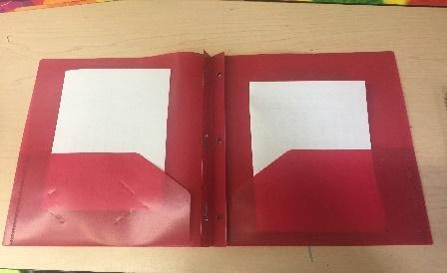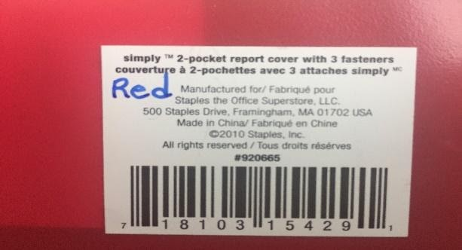
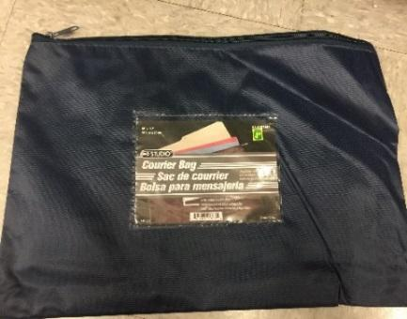
(Codes for 2-pocket plastic report cover with 3 fasteners (red)-Staples brand)
Courier Bag- Dollarama or similar bag large enough for a duo-tang to fit easily

