Gladstone Elementary School

**STUDENT SUPPLY LIST 2021-2022**

GRADE 2

20 Good quality HB pencils – (**NO FANCY PENCILS, PLEASE**.)

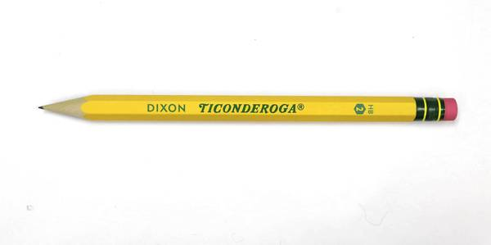1 Red pen

1 Blue pen

1 Black pen

1. Package (Maximum 24) Crayola crayons

2 Pkg. pencil crayons (24)

[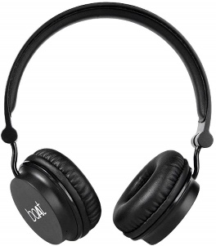](https://www.google.com/url?sa=i&rct=j&q=&esrc=s&source=images&cd=&ved=2ahUKEwjslqeYwL7iAhUu11kKHRcpABQQjRx6BAgBEAU&url=https%3A%2F%2Fwww.amazon.in%2FBoat-Rockerz-400-Bluetooth-Headphones%2Fdp%2FB01J82IYLW&psig=AOvVaw3PywBILFmrwkFfebOzCREc&ust=1559142349588773)2 Pkg of thick tip markers (10 – 12)

4 Highlighter Markers (4 different colours)

4 Pencil erasers – white

2 Pencil cases

1 Metric ruler (30 centimeters)

1 Set of headphones in a zip-lock bag with name on it

[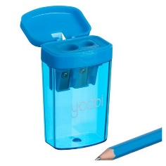](https://www.google.com/url?sa=i&rct=j&q=&esrc=s&source=images&cd=&ved=2ahUKEwiMlYTKv77iAhVKx1kKHV9oDAQQjRx6BAgBEAU&url=https%3A%2F%2Fwww.target.com%2Fp%2Fyoobi-153-two-hole-pencil-sharpener%2F-%2FA-51291766&psig=AOvVaw3EeEhrMfGtozrmreWbD66y&ust=1559142207895100)1 Good Pencil Sharpener (canister type)

1 Pair scissors (pointed end)

4 Glue sticks -- large size (Elmers or UHU)

1. 3 inch Binder

1 **Orange** Duo tang for music (must be duotang style so papers can be attached)

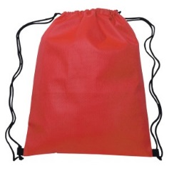1 Gym Bag, Gym Shorts and T-shirt to leave at school (Label with Name. Gym bag must be able to fit inside desk cubby. **Drawstring bags preffered**.)

1 Pair of runners with **non-marking soles**, to leave at school for indoor and gym use. Please do not send extra shoes to school.

1. Paint shirt
2. Water bottle (Students will only be able to fill water bottles this year as no fountains will be available to drink from.)

***The School will supply Agenda Books for 2021-2022 school year.***

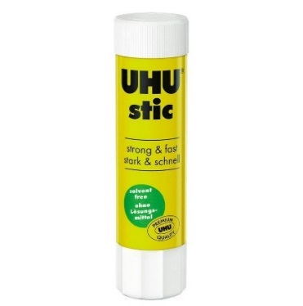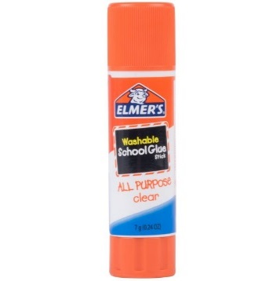**Please help us organize our supplies ahead of time:**

Pencil Case #1: 1 Eraser 2 Pencils

1 Glue stick 1 Red pen

Scissors 1 Highlighter

Pencil Case #2: Crayons

Pencil Crayons

Large Zip-Loc Bag: Put all extra supplies in a zip-loc bag with your child’s name on it.  **(They will be put** **away until your child needs them.)**

**\*\* PLEASE LABEL ALL SUPPLIES WITH STUDENT’S NAME BEFORE BRINGING TO SCHOOL, including all pencils, pencil crayons & crayons. Please also label marker lids.**

**NOTICE TO PARENTS**

*Since we are still in the planning process for the fall,*

*the supply list may have some changes or additions*

*by the end of August.*

*Class sizes and teacher assignments still need to be finalized.*

*We will have more direction from*

*Pine Creek School Division in August.*

**Your teacher will be in contact with you in September regarding a small sum of money to purchase notebooks.**