Gladstone Elementary School
STUDENT SUPPLY LIST 2021-2022
GRADE 3

20 Good quality HB pencils – (NO FANCY PENCILS, PLEASE.)
1 Red pen
1 Blue pen
1 Black pen
1 Package (Maximum 24) Crayola crayons
- Pkg. pencil crayons (24)
- Pkg of fine tip markers
1 RED Duo tang (must be duo tang style so papers can be attached)
2 Highlighter Markers
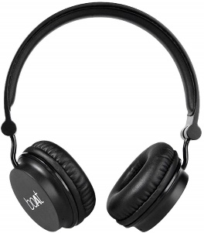
4 Pencil erasers – white
2 Pencil cases
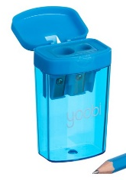
1 Metric ruler (30 centimeters)
1 Basic calculator – at dollar store for $1.00
1 Set of headphones
1 Good Pencil Sharpener (canister type)
1 Pair scissors (pointed end)
4 Glue sticks -- large size (Elmers or UHU)
1 Gym Bag, Gym Shorts and T-shirt to leave at school (Label with Name. Gym bag must be able to fit inside desk cubby.
1 Pair of runners with non-marking soles, to leave at school for indoor and gym use. Please do not send extra shoes to school.
1 Roll-on or stick deodorant (No Aerosol / Spray deodorant)
- Paint shirt
1 Water bottle (Students will only be able to fill water bottles this year as no fountains will be available to drink from.)

Please help us organize our supplies ahead of time:

Pencil Case #1: 1 Eraser 2 Pencils
1 Glue stick 1 Red pen
Scissors 1 Highlighter

Pencil Case #2: Crayons
Pencil Crayons

Large Zip-Loc Bag: Put all extra supplies in a zip-loc bag with your child’s name on it. (They will be put away until your child needs them.)

** PLEASE LABEL ALL SUPPLIES WITH STUDENT’S NAME BEFORE BRINGING TO SCHOOL, including all pencils, pencil crayons & crayons. Please also label marker lids.

NOTICE TO PARENTS

Since we are still in the planning process for the fall,
the supply list may have some changes or additions
by the end of August.

Class sizes and teacher assignments still need to be finalized.

We will have more direction from
Pine Creek School Division in August.

The School will supply Agenda Books for 2021-2022 school year.

Please send $8 in September to purchase notebooks.

